Caliphate Journal of Science & Technology (CaJoST)

ISSN: 2705-313X (PRINT); 2705-3121 (ONLINE) Research Article

Article Info
Received: 13th January 2020
Revised: 22nd February 2020
Accepted: 23rd February 2020

Department of Physics, Federal University Gusau, Zamfara State.

*Corresponding author’s email: anassalisu33@gmail.com

Cite this: CaJoST, 2020, 2, x-x

Construction of Radio Frequency Modulation (FM) Transmitter with Range of 100 Meters
*Anas Salisu and Maduka N. Chinwike
Information keep people abreast of what is happening outside and within their environment. But communities in remote areas lack this opportunity due to poor power supply in the country and outdated means of information dissemination in use. Therefore, this project implementation of Frequency Modulation (FM) transmitter received at a range of about 100 meters in free air is presented. It is divided into voice detection and modulation part of the transmitter. The components utilized in the construction are; microphone, resistors, transistors, capacitors, inductor and antenna. These preferred/selected components are due to their availability and low cost. The cost of media information dissemination constitutes major problem to individuals and institution that may wish to adopt radio broadcast as means of electronic media. The study was therefore carried to construct an FM transmitter that is cheap in price, affordable, portable and simple in maintenance to eradicate the traditional use of town criers. Based on the procedure adopted and the tests carried out, the specific findings include; appreciable range with frequency of transmission obtained on power source devised from 9V battery has been achieved in this works. The implemented FM transmitter transmits sound waves produced by human voice via a microphone to receivers at target range. The successful completion of this study has indicated that practical frequency modulated FM transmitter requiring low power can be constructed for further studies in areas of signal coupling technique need to be carried to improve the range of transmission.
Keywords: FM transmitter, FM radio receiver, Intermediate frequency, Modulation and Radio wave

1. Introduction

A transmitter is an electronic device, which, with the support of an antenna, propagates an electromagnetic signal such as radio, television or other telecommunications. The world has entered an era known as “information age” when electronic communication systems influence most of human activities. These electronic communication systems consist of three major aspects; the receiver, the channel and the source, which is the transmitter. In the early days, signal energy was produced in transmitting plants using arcs or mechanical alternators [1]. However, today a transmitter usually has a power supply, an oscillator, a modulator and amplifiers for; Audio Frequency (AF), Intermediate Frequency (IF) and Radio Frequency (RF). Transmitters are sometimes classified according to the signal information they process and radiate. Television transmitter processes sound and picture signal, while radio transmitter processes only sound. In [2] defined radio transmitter as a generator of high frequency electric current whose characteristics of amplitude, frequency, or phase may be altered or modulated in accordance with the intelligence to be transmitted. [2] further adopted the mode of modulation to classify radio transmitters. In Amplitude Modulated (AM) transmitter which is usually employed for broadcast purposes at the medium frequency, the amplitude of a carrier wave is varied in accordance with the amplitude and frequency of modulating wave. Finally, FM is one of the primitive yet effective means of wireless communication which is still used in several parts of the world. When it comes to building an FM transmitter circuit one has numerous options based on the range of communication. This project is a simple mini FM transmitter circuit that covers a range of about 100 meters.
The electromagnetic waves of radio were first conceived by James Clerk Maxwell at the London University in the year 1864. After constructing a brilliant general theory of electromagnetism expressed in mathematical equations, he concluded that light consists of transverse wave of oscillatory electric and magnetic fields at frequencies between l0¹⁴ and 10¹⁵ hertz. He suggested that similar wave having quite different frequencies might be created or discovered [3].
[4], stated that the system of transmitting two separate audio signals for stereophonic sound was approved by the Federal communications commission in 1961. He said that all radio stations in the FM bands of 88 to 108 MHz, broadcast in stereo. The technique is based on the multiplexing of a subcarrier signal with the main RF carrier of the station
The use of town criers can be said to be outdated because their information dissemination is not efficient and is stressful. Therefore, with the development of this kind of broadcasting medium, information can be passed effectively in a shorter possible time, since people move around with their mobile radio system, this as a result of the local advancement in communication technology. Moreover, any new transmitter type need a constant power supply and high voltage system design, this requirement of the transmitter constitutes major problems to individual or institution that may wish to adopt broadcasting system due to less power stability in Nigeria. The implementation of FM transmitter can remedy these problems, since its power supply is derived from low voltage system that is safe for local transmission.
The purpose of this project work is to implement a radio frequency modulation transmitter that allow portable audio devices to make use of sound of audio system or Car stereo without requiring a wired connection between them. The sound is then broadcast in frequency band and pick up by receivers within a distance of 100 meters.
The short-range FM radio transmitter would be of immense benefit to local communities in that if adopted, it would ease their information dissemination. It would be cheap enough to be procured and maintained.
2. Reviewed Works
They [5], designed and constructed a 10 watt FM transmitter to be received at arrange of about 4km in free air. They made use of some materials which include; Copper laminate plate gross paint, electric technician Knife, Soldering Iron (40watts), alloy lead, variety of resistors, inductor, feeder wire, antenna, Jp1-Jp5 etc. The procedure followed during their research was mixture, screening, dispatch, developing, removing, resist drilling holes and soldering. Based on the procedures adopted and the tests carried out, the specific findings include appreciable range with stable frequency of transmission obtained on power source devised from 12V lead acid battery.
[6] did analysis and implementation of Frequency Modulation in order to make a Frequency Transmitter, using some components like CD4046 Microcontroller, amplifier LM741, resistors, capacitors, and battery. In their work they use different methods in designing the transmitter which is P-Spice circuit of FM transmitter, Simulation of FM transmitter, and transmitter experimental result. At the end of everything they were able to construct the device.
3. Materials and Methods
Figure 1 is the block diagram of the frequency modulation (FM) transmitter, it consists of; microphone, audio pre-amplifier (AF) modulator, oscillator, radio frequency (RF) amplifier and transmitting antenna. There are two frequencies in the FM signal, one is carrier frequency and the other is audio frequency. The audio frequency modulates the carrier frequency. The frequency modulation FM signal is obtained by differing the carrier frequency by allowing the audio frequency (AF), where microphone is used for converting the information to be transmitted into an electrical signal, modulator is used for combining the information containing signal with a radio frequency carrier wave, RF-Amplifier is used for reconverting part of the transmitted waves, an oscillator is an amplifier which provides its own input signal that is derived from the output signal and to generate the radio frequency (RF) carrier waves, transmitting antenna is use for launching the radio wave into air space,
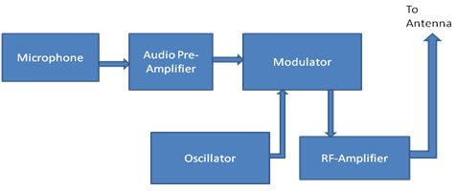
Figure 1. Block diagram of FM transmitter circuit
The complete circuit diagram the FM transmitter is as shown in Figure 2, when power is supplied to the FM transmitter, the transmitter will transmit sound wave via microphone produced by human voice and picked up by the receivers. The circuit is divided into two parts as shown in Figures 3a and 3b for better understanding of its operation.
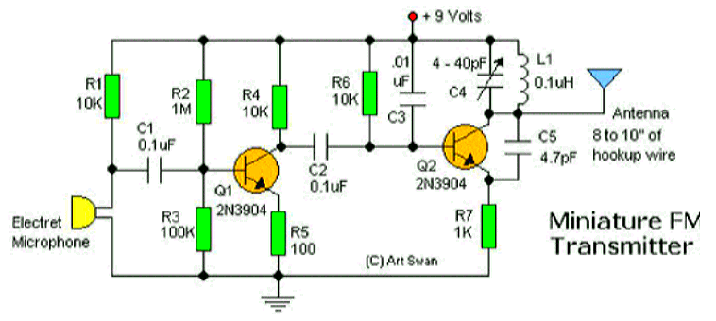Figure 2. Complete circuit diagram of FM transmitter [7]
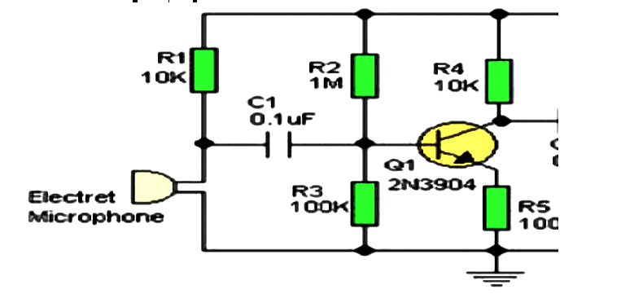
Figure 3a. Voice Detection Circuit of the FM transmitter [7]
Figure 3a is audio frequency which is used to modulate the carrier frequency, when power is supplied on the FM transmitter, electret microphone would start converting the information to be transmitted into an electrical signal and single stage transistor amplifier to amplify the signals obtained from the microphone. The capacitor was used to block the DC components in the signals whereas Resistor fixes the sensitivity of the microphone. The amplifier was built around Transistor where Resistors and Provides the biasing voltage to the base of the transistor .
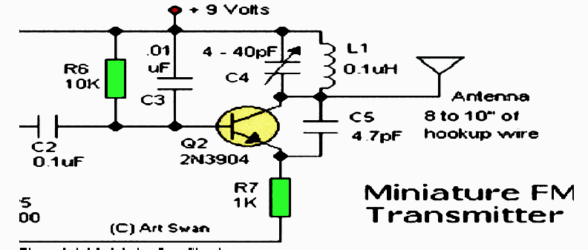
Figure 3b. Modulation Circuit of the FM transmitter [7]
The circuit in figure 3b is the modulation part which consists of a tank circuit along with transistor . The LC tank circuit provides the sustained oscillation for the FM modulator. The formation of the oscillating tank circuit is done via the transistor of 2N3904 by using the inductor and trimmer capacitor. An NPN transistor used for general purpose amplification. When current is passed at the inductor and variable capacitor, the tank circuit will oscillate at the resonant carrier frequency of the FM modulation. The negative feedback will be the capacitor to the oscillating tank circuit. To generate the radio frequency carrier waves then send to antenna couples energy from the transmitter circuits into free space, thus serving to radiate the transmitter output as radio waves. The capacitor was employed to remove the DC components in the output amplified signal from . The was meant for decoupling and to provide the bias voltage. Where ceramic capacitor was added to keep the tank circuit vibrating thereby ensuring the sustained oscillations from the tank circuit. performs the function of current limiting. A simple wire measuring 8 to 10 inches can serve the purpose of antenna in the above circuit. But 45 inches of antenna was used.
Table 1. Details/Specifications of Components Used
Components | Model/Rating | Quantity
Ceramic capacitors | 0.1µF | 3
Trimmer capacitor | 40рF | 1
Ceramic capacitor | 4рF | 1
Resistors |  | 7
Transistor | 2N3904 | 2
Electrets Microphone |  | 1
Battery | 9V | 1
Switch |  | 1
Copper and jumper wire | 18 Inches
Soldering iron | 40W | 1

The circuit components, their ratings or specifications and quantities used for the implementation of FM transmitter are as contained in Table 1.
4. Results and Discussion
After construction of the gadget as can be seen in Figure 4, first test was done six hours per-day, and was repeated for eighteen days and the second test was done for a whole day and results obtained from the performance test showed that the transmitter device has transmitted sound waves effectively by human voice through a microphone which is audible, reachable and clearly picked up by receivers within the coverage and appeared frequency channel during test measured in frequencies range of 78.8 to 106.8 MHz.
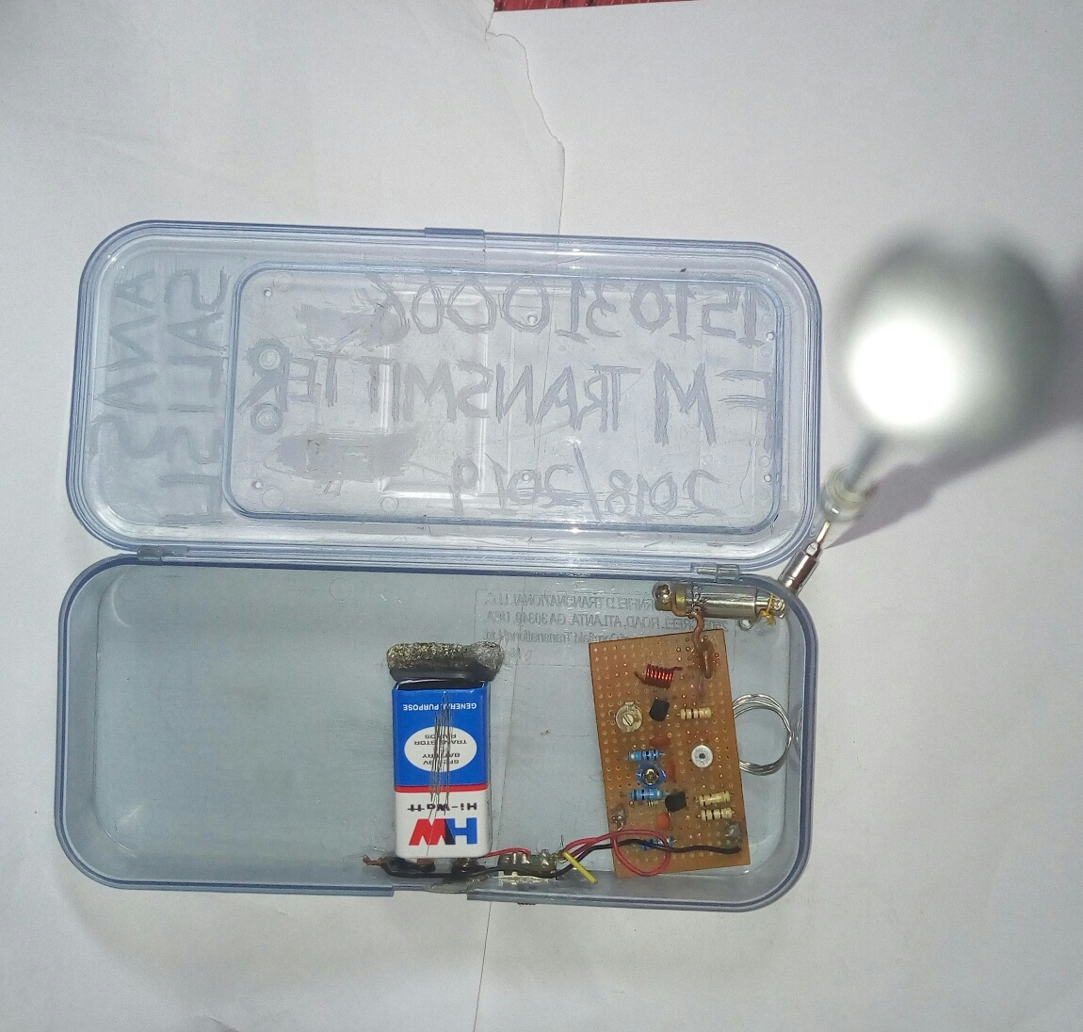
Figure 4. The constructed FM transmitter during test

Result test was conducted at different locations to verify the working condition of the constructed device which generally, uses Very High Frequency (VHF) radio frequencies range of 78.8 to 106.8 MHz. Also to have a clear dissemination of information from the transmitter to receivers, a user must give little distance of about two or more feet from the transmitter device.
5. Conclusion
The test result of this work which is the outcome of construction procedures has revealed the successful achievement of the primary objective; construction of an FM transmitter of appreciable range operating on 9V power supply. Because of the impressive good result, obtained from the usability test, the FM transmitter is audible, reachable and clearly within the range of 100 meter. The successful completion of the study has indicated that practical FM transmitter requiring low power input can be constructed. Further research can be carried out to improve and expand the scope.
Conflict of interest
The authors declare no conflict of interest.
References
[1] L. Farlax, "Transmitter-encyclopaedia articles about transmitters". 2005. http:wysiwg: 118/file: al; transmitter. [Accessed August 7, 2019]
[2] L. Lycos, "Radio Communication Labrotory-bult for Transmitters". 1987. http://memberstroipor.com/rclindia/trans.html. [Accessed August 8, 2005]
[3] A. R. Chipman, "Radio Theory and Technology". Encyclopaedia Americana, New York: vol. 23, pp 161 -1 74. 2000.
[4] B. Grob, Electronics Circuits and Applications, McGraw-Hill International Edition New York: 1982.
[5] T. C. Ogbuanya, A. Sule, and J. Bakare, “The Design and Construction of a Frequency Modulated (FM) Transmitter with Output Capacity of 10 Watts and Range above 4km” International Journal of Applied Engineering Research vol. 18(12): pp7516-7523, 2017.
[6] T. Sarker, T. Rahman, R. M. Al Muntasiru, U. N. Kamaruzzaman, V. K. SArker, and S. Islam, "Analysis and Implementation of Frequency Modulation in Order to make a Frequency Transmitter”. International Journal for Research in Applied Science & Engineering Technology (IJRASET) vol. I (5): pp 367-372, 2017.
[7] ASCAS, “The Ultimate FM Transmitter” 2014. http//www.instructables.com. [Accessed July 16, 2019]

